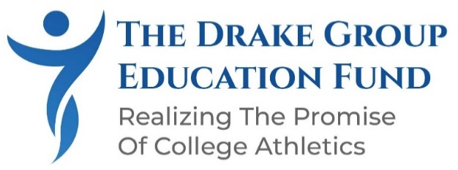

SYMPOSIUM STUDENT SPONSORSHIP
INSPIRING THE NEXT GENERATION OF CHANGEMAKERS

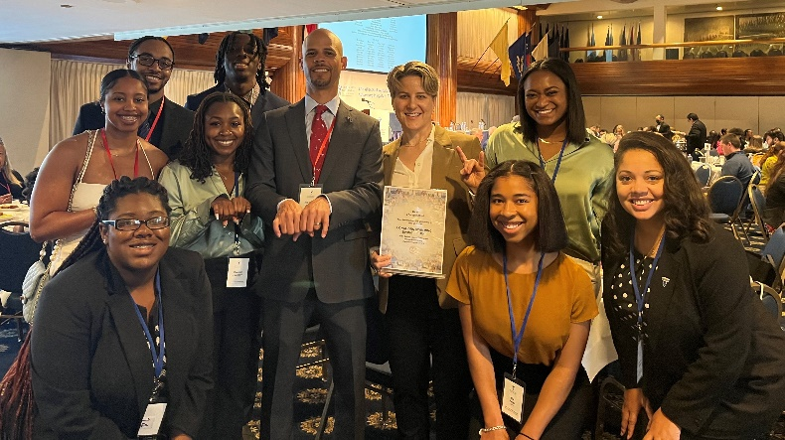

A DONATION IN ANY AMOUNT TO SUPPORT STUDENT ATTENDANCE
OR
A STUDENT BENEFACTOR TABLE SPONSORSHIP -$2,000.00

CLICK HERE TO MAKE A TAX DEDUCTIBLE DONATION

Our Donors and Sponsors Make It Possible for Students to Attend at No Cost. Conferences such as the Allen Sack National Symposium are invaluable professional development activities for students that they typically cannot afford. The Drake Group Education Fund is dedicated to removing financial barriers and making this enriching experience accessible to all students. They get to hear and meet members of the national sports and higher education media, leaders and key influencers from national sports governance organizations and higher education organizations working in their chosen career field, and nationally recognized experts in the economic and legal aspects of college athletics.

Up to one hundred sports management, sports law, and other currently enrolled students in sports-related majors from colleges and universities within 60 miles of Washington D.C. (with preference given to students from HBCUs and other low-resourced institutions) will attend at no charge thanks to sponsors and donors. We believe they are the future leaders who will ensure that college athletics is a safe and rewarding experience, free from race and sex discrimination, and delivering on the promise of receiving a meaningful education.

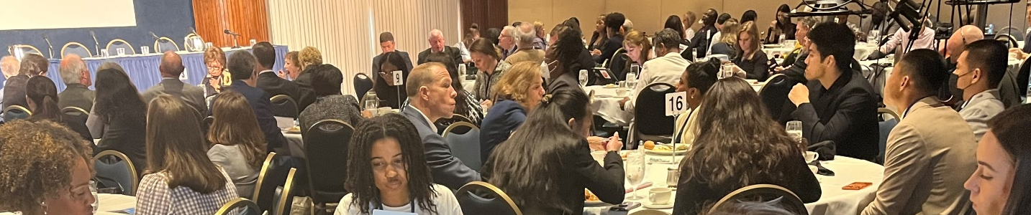

Student attendees will receive:

- a complimentary subscription to the TDGEF newsletter and programming;
- a complimentary student membership in The Drake Group, our sister organization working directly with Congress on policy issues;
- issue summaries and research papers on all topics covered at the symposium; and
- the opportunity to participate in the closing cocktail/networking gathering that enables them to meet and interact with panelists and experts.

